AWS Task-1

Task Description:
Create a windows Vm machine in AWS and connect with RDP open CMD in windows share the about system info.

Techstacks needs to be used :
- AWS EC2 (windows)
- RDP (Preavailable in Windows)
Created EC2 instance on AWS machine
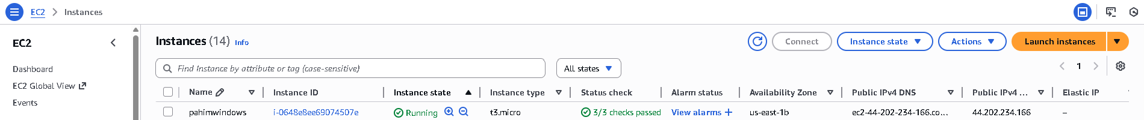

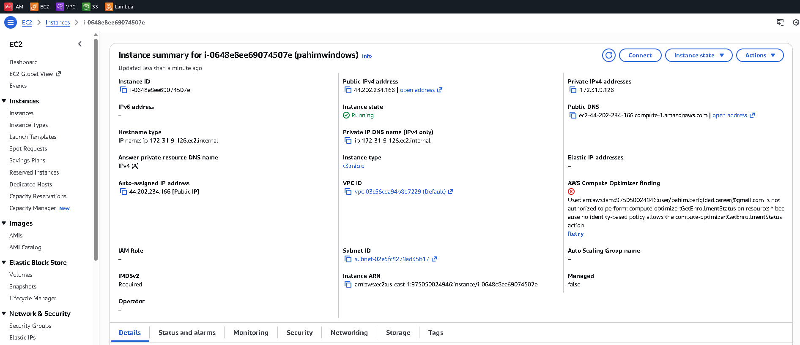

Inbound rule edited and allowed RDP and opened the port 3389
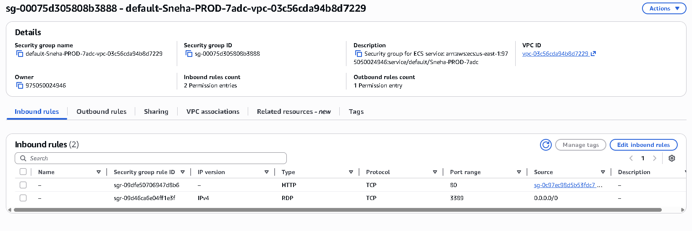

Decrypted the password using the .pem file
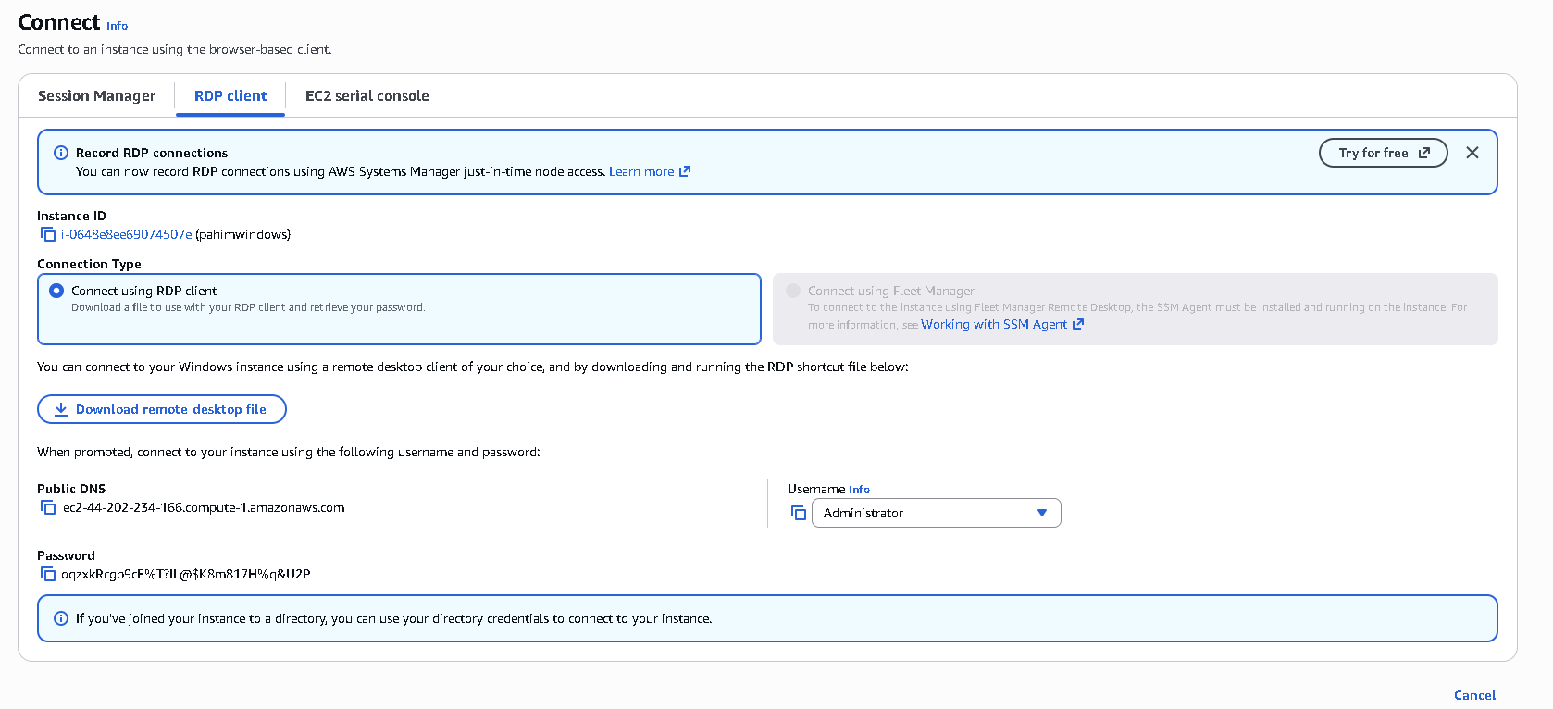

Connected the Remote Desktop
Opened command prompt and executed systeminfo
